Weekly Report(Up until 8th October, 2015)
Anirudh Tiwari

Work Done
- To establish the importance of length, radius of gyration and interaction energy in classifying single domain proteins from two domain proteins. I plotted graphs(length, radius of gyration and interaction energy) for contiguous and non-contiguous two domain proteins first separately then together, comparing them with single domain proteins.

- I also extracted the class information of every domain in my data set based from SCOP.

Results
The following 6 graphs shows the results. Note:

Red Dots → Single Domain Proteins
Blue Dots → Contiguous Two Domain Proteins
Green Dots → Non-Contiguous Two Domain Proteins

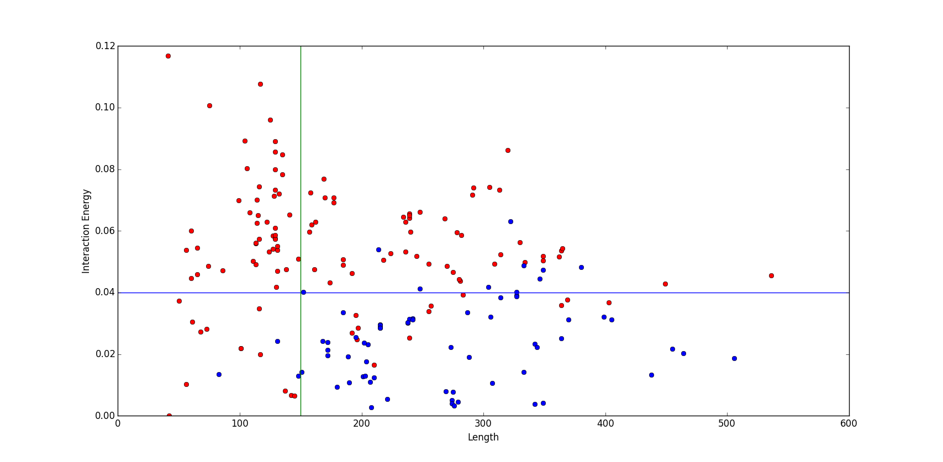

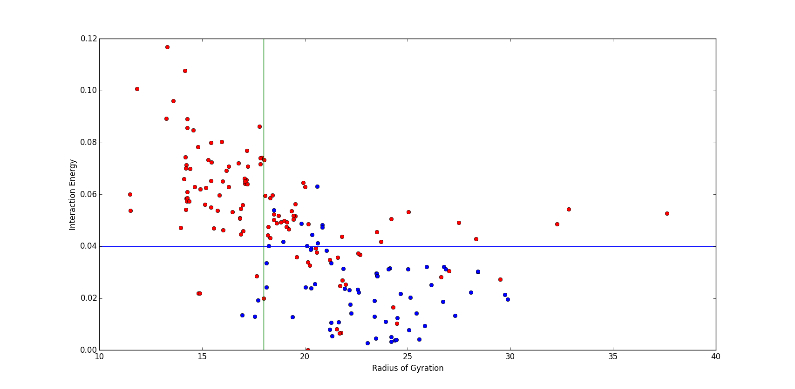

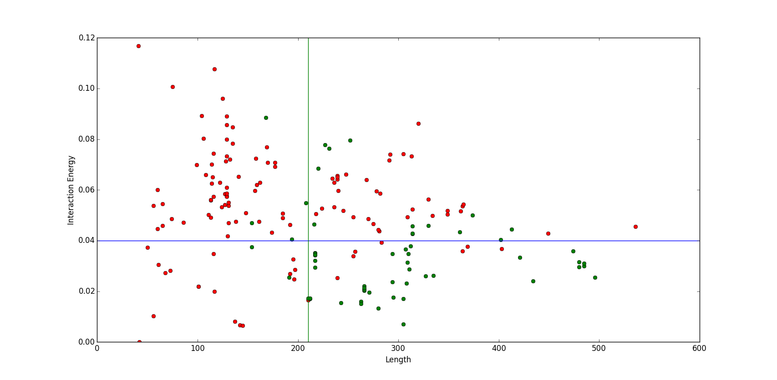

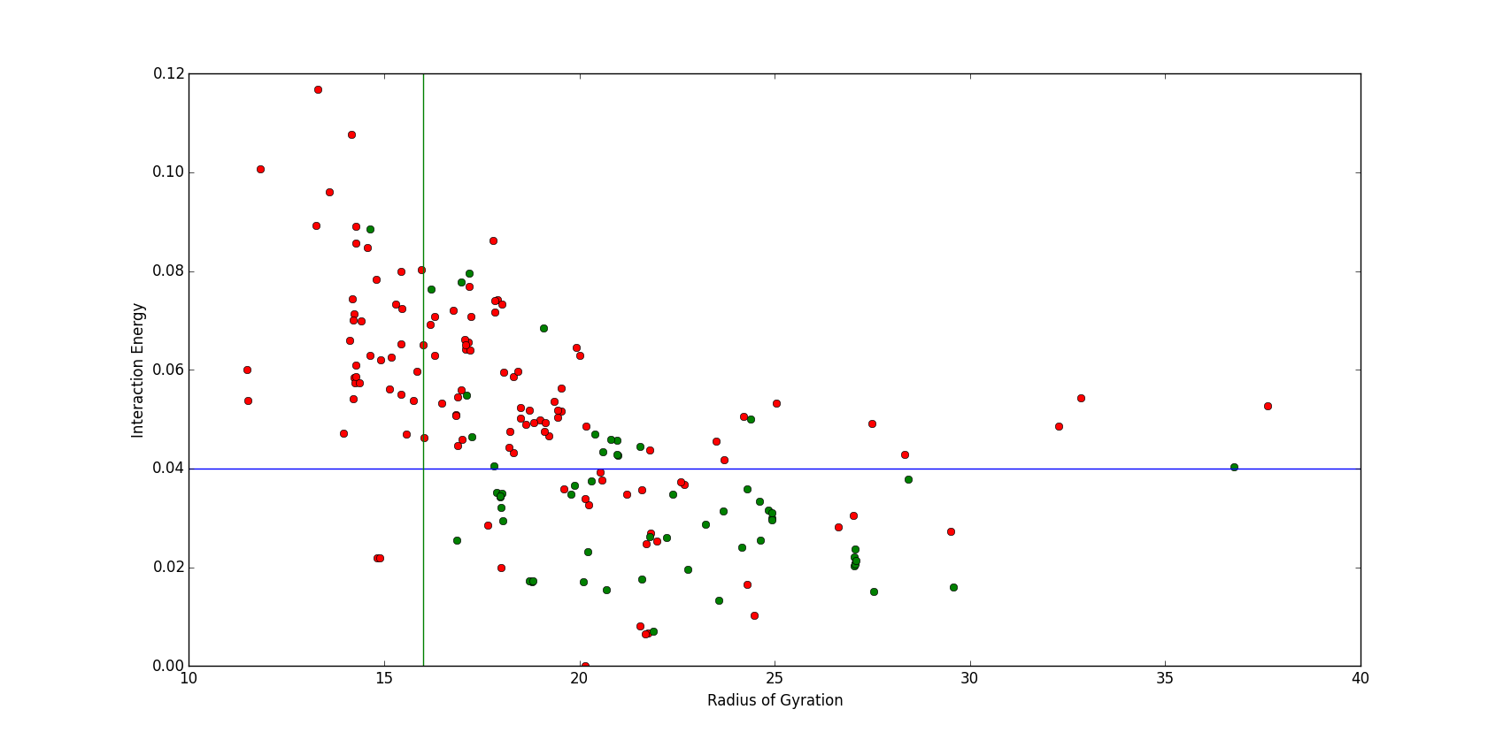

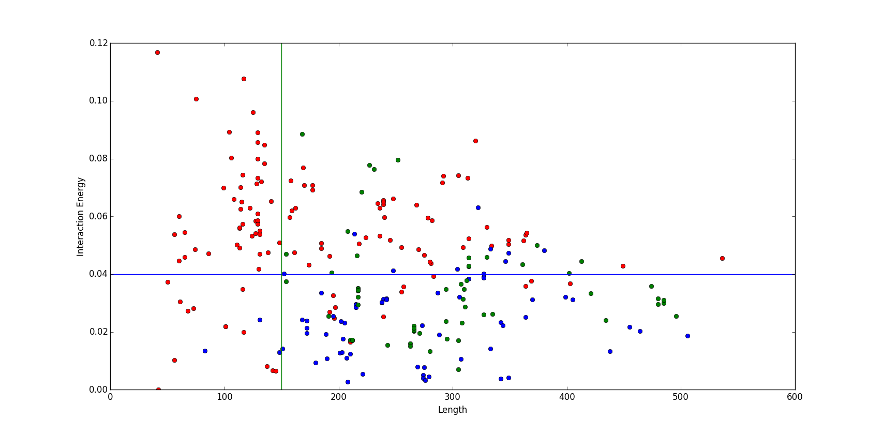

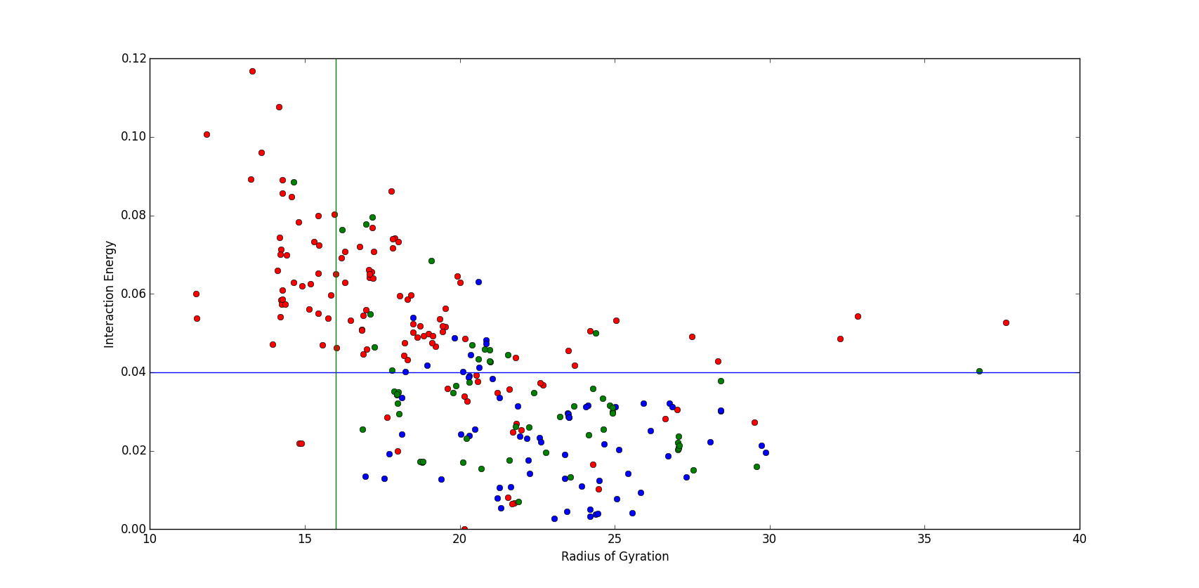

Values of Length, Interaction Energy & Radius of Gyration for distinguishing single domain proteins from two domain proteins.

 | Length | Interaction Energy | Radius of Gyration | True Positives | False Positives
Contiguous | >=150 | <=0.04 | >=18.0 | 55/69 | 11/120
Non-Contiguous | >=210 | <=0.04 | >=16.0 | 40/59 | 8/120
Both | >=150 | <=0.04 | >=16.0 | 98/128 | 12/120

It was noted that the role of Radius of gyration was not much in distinguishing single domain from two domain proteins.

Next Steps
- Try to find out if length and interaction energy can help in distinguishing two domain from three domain and so on.

- Now with SCOP data available, repeat the same exercise and find out if the proteins are classified in a better manner.

